**GO GREEN USING SATELLITE IMAGE PROCESSING**

Submitted to North Maharashtra University, Jalgaon in Partial Fulfillment of the

Requirements for the Degree of BACHELOR OF TECHNOLOGY in

Computer Engineering.

By

WANI BHAVESH GAJENDRA (1741011)

CHAUDHARI VAIBHAV ANNA (1741014)

DATKAR PAVAN GANESH (1741017)

FEGADE SHREYAS MANOJ (1741019)

**Guide**

Mr. H.D. GADADE



**DEPARTMENT OFCOMPUTER ENGINEERING**

**GOVERNMENT COLLEGE OF ENGINEERING, JALGAON 425002**

**GOVERNMENT COLLEGE OF ENGINEERING, JALGAON 425002**

**Department of Computer Engineering**

**CERTIFICATE**



This is certify that the **Project** entitled, **“GO GREEN USING SATELLITE IMAGE PROCESSING”**, which is being submitted here with for the award of Bachelor of Technology in Computer Engineering is the result of the work completed by **Bhavesh Wani, Vaibhav Chaudhari, Pavan Datkar and Shreyas Fegade** under my supervision and guidance within the four walls of the institute and the same has not been submitted elsewhere for the award of any degree.

(Mr. H. D. GADADE) (Prof. D. V. Chaudhari)

Guide Head of Computer Engineering

(Dr. R. D. Kokate)

Principal Examiner

**DECLARATION**

I hereby declare that the **Project** entitled, **“GO GREEN USING SATELLITE IMAGE PROCESSING”** was carried out and written by us under the guidance of Mr. H. D Gadade, Department of Computer Engineering, Government College of Engineering, Jalgaon**.** This work has not been previously formed the basis for the award of any degree or diploma or certificate nor has been submitted elsewhere for the award of any degree or diploma.

Bhavesh Wani

Vaibhav Chaudhari

Pavan Datkar

Shreyas Fegade

Place: Jalgaon

Date:

**ACKNOWLEDGEMENT**

It is my proud privilege and duty to acknowledge the kind of help and guidance received from several people in preparation of this report. It would not have been possible to prepare this report in this form without their valuable help, cooperation and guidance.

Our sincere thanks to **Mr. H. D. Gadade,** Department of Computer Science and Engineering, for his valuable suggestions and guidance throughout the period of this report.

I express my sincere gratitude to our guide, **Prof. D.V. Chaudhari,** Head of Department of Computer Science and Engineering, for guiding us in investigations for this seminar and in carrying out experimental work.

          I am thankful to **Honorable Principal, Dr. R. D. Kokate** for having taken interest in all the activities related to studies.

I would also like to thank staff members and non-teaching staff of Computer Department and other department, family and friends for their timely help and encouragement.

**INDEX**

|  |  |  |
| --- | --- | --- |
| **Chapter**  **No** | **Title** | **Page No** |
|  | Certificate | i |
|  | Declaration | ii |
|  | Acknowledgement | iii |
|  | Abstract | iv |
|  | List of Figures | vi |
| 1 | Introduction | 1 |
|  | 1.1 Introduction | 1 |
|  | 1.2 Problem statement | 1 |
|  | 1.3 Objectives | 1 |
|  | 1.4 Challenges  1.5 Outline | 2  2 |
| 2 | Literature Survey | 3 |
| 3 | Methodology and Implementation | 5 |
|  | 3.1 Design  3.1.1 Working | 5  5 |
|  | 3.1.2 Installation  3.1.3 Running | 5  6 |
|  | 3.2 Algorithms  3.3 UML Diagrams  3.3.1 Sequence Diagram  3.3.2 Use Case Diagram  3.3.3 Component Diagram  3.3.4 Deployment Diagram  3.3.5 State Chart Diagram  3.3.6 Data Flow Diagram  3.3.7 Activity Diagram | 7  9  9  9  10  10  11  11  12 |
| 4 | System Design | 13 |
|  | 4.1 Reading the image through Web-input | 13 |
|  | 4.2 Calculating pixels with Green shade | 13 |
|  | 4.3 Excluding all the pixels | 14 |
|  | 4.4 Creating rectangular box around contour  4.5 Analysis  4.5.1Amount of Oxygen released in Region  4.5.2 Amount of Oxygen consumed by human  4.5.3 Amount of Carbon Dioxide generated | 14  15  15  15  16 |
| 5 | Result and Discussion | 17 |
| 6 | Conclusion and future scope | 25 |
|  | References | 26 |
|  |  |  |
|  | **LIST OF FIGURES**   |  |  |  | | --- | --- | --- | | **Figure No.** | **Title** | **Page No.** | | 3.1 | Flowchart for proposed concept | 8 | | 3.3.1 | Sequence Diagram | 9 | | 3.3.2 | Use case Diagram | 9 | | 3.3.3 | Component Diagram | 10 | | 3.3.4 | Deployment Diagram | 10 | | 3.3.5 | State Chart Diagram | 11 | | 3.3.6 | Data Flow Diagram | 11 | | 3.3.7 | Activity Diagram | 12 | | 5.1 | Original Satellite Image | 17 | | 5.2 | Masked Image | 18 | | 5.3 | Contour Image | 18 | | 5.4 | Sign-up Window | 19 | | 5.5 | Login Window | 19 | | 5.6 | Dashboard Window | 20 | | 5.7 | Upload Window | 20 | | 5.8 | Upload Image Window | 21 | | 5.9 | Image Upload Successful Window | 21 | | 5.10 | Image Report Window | 22 | | 5.11 | Report Window | 22 | | 5.12 | Technical Stuff Window | 23 | | 5.13 | Technical Stuff Window | 23 | | 5.14 | Technical Stuff Window | 24 | | 5.15 | My Uploads Window | 24 | |  |
|  |  |  |
|  |  |  |
|  |  |  |

**ABSTRACT**

To promote sustainable development, the smart city implies a global vision that merges artificial intelligence, big data, decision making, information and communication technology (ICT), and the Internet-of-Things (IOT). These processes above are related for solving real life problems. World population is increasing day by day. So, it has become important to grow sufficient amount of tree to feed oxygen for such a huge population. But with the time passing by, due to deforestation levels of oxygen are depleting to a large extent day by day.

Beside that many countries economy developed but suffering through pollution. Detection of trees through some automatic technique will be beneficial as it requires a large amount manual work for monitoring/counting no of trees. In this paper a method is studied to count the number of trees using satellite image processing technique.

Keywords: Image processing, Air Quality Index, Amount of Oxygen, Amount of Carbon dioxide, Detected trees.

**Chapter 1**

**INTRODUCTION**

**1.1 Introduction**

Our project idea is to develop an application to detect greenery in specific area, captured with Google Earth Pro software (i.e. Satellite Image of Earth). Our aim is to detect number of trees, calculate amount of oxygen released by these trees in that particular area. On the basis of number of people (population in that area) provided as an input by the user, we are doing the analysis of amount of Carbon dioxide exhaled by these people as well as Carbon dioxide generated due to the automobiles running in that locality. On the basis of this data collection we can analyze the amount of Oxygen required in that locality or it is present in ample amount. If the analyzation tells that the amount of Oxygen is less than the amount of Oxygen should be available, this will indicate that there are a smaller number of tress in that area or the greenery should be increased. Overall objective is to detect the air quality index from the above data analysis.

**1.2 Problem Statement: -**

Plants are really important for the planet and for all living things. Plants absorb carbon dioxide and release oxygen from their leaves, which humans and other animals need to breathe. So, it is very necessary to check the presence of proper number of trees in the region. Hence our aim is to detect number of trees and analyze air quality in the region.

**1.3 Objectives**

* **Count numbers of trees**: In this objective we are counting no of trees form image taken form Google Earth Pro.
* **Amount of Oxygen released:** In this objective we are calculating amount of oxygen released by number of trees detected in that area.
* **Amount of Oxygen consumed:** In this objective we are calculating amount of Oxygen consumed or required in that locality.
* **Amount of Carbon dioxide generated:**

1. In this objective the aim is to analyze the amount of Carbon dioxide generated by the peoples in that locality.
2. Also considering the amount of Carbon dioxide generated due to the automobiles travelling from that area daily.

* **Greenery result:** Considering the data of amount of oxygen and carbon dioxide, we can analyze the final result of ample presence of greenery in that area.
* **Calculating air quality index.**

**1.4 Challenges**

**1.4.1 Existing Methods:**

* Manual trees Analysis
* Distinguishing trees in the region by marking them with specific symbols
* Ground survey is one of the most basic methods for gathering urban forestry data

**1.4.2 Drawbacks:**

* High Computational load
* Use of large amount of man power
* Unable to collect data from the restricted places/region is skipped where it is not possible to collect data due to some reasons

**1.4.3 Proposed method:**

* To detect the number of trees using the satellite imagery.
* Provide further details about the region by getting information like current population, approx. vehicles running in that region on the basis of which the air quality index of the region will be analysed.

**1.5 Outline**

Chapter 1 consists of Introduction, problem statement, objectives, challenges and outline. Chapter 2 consists of Literature survey. Chapter 3 consists Methodology and Implementation, design, working, installation, running and algorithms. Chapter 4 consists System design. Chapter 5 consists of Result and Discussion. Chapter 6 consists of Conclusion and Future scope.

**Chapter 2**

**LITERATURE SURVEY**

Paper [1] presents classification and detection tech-

niques that can be used for plant leaf disease classifi-

cation. Here preprocess is done before feature extrac-

tion. RGB images are converted into white and then

converted into grey level image to extract the image

of vein from each leaf. Then basic Morphological

functions are applied on the image. Then the image is

converted into binary image. After that if binary pixel

value is 0 its converted to corresponding RGB image

value. Finally by using pearson correlation and Domi-

nating feature set and Naïve Bayesian classifier dis-

ease is detected.

In paper [20 there are four steps. Out of them the first

one is gathering image from several part of the coun-

try for training and testing. Second part is applying

Gaussian filter is used to remove all the noise and

thresholding is done to get the all green color compo-

nent. K-means clustering is used for segmentation.

All RGB images are converted into HSV for extract-

ing feature

Paper [1] presents classification and detection tech-

niques that can be used for plant leaf disease classifi-

cation. Here preprocess is done before feature extrac-

tion. RGB images are converted into white and then

converted into grey level image to extract the image

of vein from each leaf. Then basic Morphological

functions are applied on the image. Then the image is

converted into binary image. After that if binary pixel

value is 0 its converted to corresponding RGB image

value. Finally by using pearson correlation and Domi-

nating feature set and Naïve Bayesian classifier dis-

ease is detected.

In paper [20 there are four steps. Out of them the first

one is gathering image from several part of the coun-

try for training and testing. Second part is applying

Gaussian filter is used to remove all the noise and

thresholding is done to get the all green color compo-

nent. K-means clustering is used for segmentation.

All RGB images are converted into HSV for extract-

ing feature

Paper [1] presents classification and detection tech-

niques that can be used for plant leaf disease classifi-

cation. Here preprocess is done before feature extrac-

tion. RGB images are converted into white and then

converted into grey level image to extract the image

of vein from each leaf. Then basic Morphological

functions are applied on the image. Then the image is

converted into binary image. After that if binary pixel

value is 0 its converted to corresponding RGB image

value. Finally by using pearson correlation and Domi-

nating feature set and Naïve Bayesian classifier dis-

ease is detected.

In paper [20 there are four steps. Out of them the first

one is gathering image from several part of the coun-

try for training and testing. Second part is applying

Gaussian filter is used to remove all the noise and

thresholding is done to get the all green color compo-

nent. K-means clustering is used for segmentation.

All RGB images are converted into HSV for extract-

ing feature

Paper [1] presents classification and detection tech-

niques that can be used for plant leaf disease classifi-

cation. Here preprocess is done before feature extrac-

tion. RGB images are converted into white and then

converted into grey level image to extract the image

of vein from each leaf. Then basic Morphological

functions are applied on the image. Then the image is

converted into binary image. After that if binary pixel

value is 0 its converted to corresponding RGB image

value. Finally by using pearson correlation and Domi-

nating feature set and Naïve Bayesian classifier dis-

ease is detected.

In paper [20 there are four steps. Out of them the first

one is gathering image from several part of the coun-

try for training and testing. Second part is applying

Gaussian filter is used to remove all the noise and

thresholding is done to get the all green color compo-

nent. K-means clustering is used for segmentation.

All RGB images are converted into HSV for extract-

ing feature

Paper [1] A manual census of trees over a large geographic area can be very costly. In this regard, this research focuses on the Google Earth image-based detection and counting of Palmyra trees in the northern part of Sri Lanka. The detection results in successfully extracted Palmyra among other vegetation in Google Earth images and shows with a precision of 92.6% and recall of 88%. Google Earth imagery is free of cost and available in high resolution, having been gathered via different sources.

In paper [2] The purpose of oil palm tree detection is to locate or count oil palm trees on map, aerial image or satellite imagery. This information is the key factor for oil palm plantation management and monitoring in each plantation area.

The paper [3] presents the information about the breathing rates and breathing air constituents by human body. The ample constituents that are essential for the breathing purpose, etc.

The paper [4] gives the information about the oxygen level required for respiration of human body. The human lung consumes about 5-6 ml oxygen per minute at an esophageal temperature of 28 degrees C. Prebypass whole-body oxygen consumption measured at nearly normothermic conditions was 198 +/- 28 ml/min. Mean lung and whole-body respiratory quotients were similar (0.84 and 0.77, respectively).  Extrapolating lung oxygen consumption to 36 degrees C suggests that the lung consumes about 11 ml/min or about 5% of total body oxygen consumption. Because the amount of enflurane diffused from the systemic circulation into the bronchial system during cardiopulmonary bypass was less than 0.1%, the contribution of bronchial blood flow to lung gas exchange can be assumed to be negligible. The lung consumes about 5% of whole-body oxygen uptake.

In paper [5] “To adopt/develop an Air Quality Index (AQI) based on national air quality standards, health impacts and monitoring programme which represents perceivable air quality for general public in easy to understand terms and assist in data interpretation and decision-making processes related to pollution mitigation measures

Paper [6] The purpose of this article is to estimate the oxygen production

by urban forests in select cities and nationally.

Oxygen Production by Trees:

Photosynthesis: *n*(CO2) + *n*(H2O) + light → (CH2O)*n* + *n*O2

Respiration: (CH2O)*n* + *n*O2 → *n*(CO2) + *n*(H2O) + energy

If carbon dioxide uptake during photosynthesis exceeds carbon dioxide release by respiration during the year, the tree will accumulate carbon (carbon sequestration). Thus, a tree that has a net accumulation of carbon during a year (tree growth) also has a net production of oxygen. The amount of oxygen produced is estimated from carbon sequestration based on atomic weights:

net O2 release (kg_yr) = net C sequestration (kg_yr) × 32_12

Paper [7] Urban vegetation, particularly trees provides a wide spectrum of ecosystem services which include upgradation of air quality, stabilizing temperature, reduction in ultraviolet radiation, oxygen generation, carbon sequestration, habitat of several flora and fauna (enhancement of biodiversity) aesthetic beauty etc...

In paper [8] Scientists approximated a safe oxygen consumption of 50 litres per hour for a human. Meanwhile, a leaf gives off about five millilitres of oxygen per hour. A single healthy tree can absorb carbon dioxide at a rate of 48 lbs/year and can release enough oxygen back into the atmosphere to support 2 human beings. On average, one tree produces nearly 260 pounds of oxygen each year. Two mature trees can provide enough oxygen for a family of four.

In paper [9] This provides the details about the latest survey about the emissions done by the vehicles like motorcycle, car, bus, etc. Based on their engines CC. They provide the amount of Carbon Dioxide emitted by these vehicles per km.

In paper [10] It provide the details calculation about the Carbon Dioxide emitted by the human body that gives estimation of **0.9 kilograms of carbon dioxide for each day per human.**

Paper [1] presents classification and detection tech-

niques that can be used for plant leaf disease classifi-

cation. Here preprocess is done before feature extrac-

tion. RGB images are converted into white and then

converted into grey level image to extract the image

of vein from each leaf. Then basic Morphological

functions are applied on the image. Then the image is

converted into binary image. After that if binary pixel

value is 0 its converted to corresponding RGB image

value. Finally by using pearson correlation and Domi-

nating feature set and Naïve Bayesian classifier dis-

ease is detected.

In paper [20 there are four steps. Out of them the first

one is gathering image from several part of the coun-

try for training and testing. Second part is applying

Gaussian filter is used to remove all the noise and

thresholding is done to get the all green color compo-

nent. K-means clustering is used for segmentation.

All RGB images are converted into HSV for extract-

ing feature

Paper [1] presents classification and detection tech-

niques that can be used for plant leaf disease classifi-

cation. Here preprocess is done before feature extrac-

tion. RGB images are converted into white and then

converted into grey level image to extract the image

of vein from each leaf. Then basic Morphological

functions are applied on the image. Then the image is

converted into binary image. After that if binary pixel

value is 0 its converted to corresponding RGB image

value. Finally by using pearson correlation and Domi-

nating feature set and Naïve Bayesian classifier dis-

ease is detected.

In paper [20 there are four steps. Out of them the first

one is gathering image from several part of the coun-

try for training and testing. Second part is applying

Gaussian filter is used to remove all the noise and

thresholding is done to get the all green color compo-

nent. K-means clustering is used for segmentation.

All RGB images are converted into HSV for extract-

ing feature

Paper [1] presents classification and detection tech-

niques that can be used for plant leaf disease classifi-

cation. Here preprocess is done before feature extrac-

tion. RGB images are converted into white and then

converted into grey level image to extract the image

of vein from each leaf. Then basic Morphological

functions are applied on the image. Then the image is

converted into binary image. After that if binary pixel

value is 0 its converted to corresponding RGB image

value. Finally by using pearson correlation and Domi-

nating feature set and Naïve Bayesian classifier dis-

ease is detected.

In paper [20 there are four steps. Out of them the first

one is gathering image from several part of the coun-

try for training and testing. Second part is applying

Gaussian filter is used to remove all the noise and

thresholding is done to get the all green color compo-

nent. K-means clustering is used for segmentation.

All RGB images are converted into HSV for extract-

ing feature

Paper [1] presents classification and detection tech-

niques that can be used for plant leaf disease classifi-

cation. Here preprocess is done before feature extrac-

tion. RGB images are converted into white and then

converted into grey level image to extract the image

of vein from each leaf. Then basic Morphological

functions are applied on the image. Then the image is

converted into binary image. After that if binary pixel

value is 0 its converted to corresponding RGB image

value. Finally by using pearson correlation and Domi-

nating feature set and Naïve Bayesian classifier dis-

ease is detected.

In paper [20 there are four steps. Out of them the first

one is gathering image from several part of the coun-

try for training and testing. Second part is applying

Gaussian filter is used to remove all the noise and

thresholding is done to get the all green color compo-

nent. K-means clustering is used for segmentation.

All RGB images are converted into HSV for extract-

ing featur

**Chapter 3**

**METHODOLOGY AND IMPLEMENTATION**

This chapter include various aspects that describes various system of methods used in classification.

**3.1 Design**

Tree counting is an essential need in today’s world. The design is made such that we have to just enter the satellite image (taken using the Google Earth Pro software), and provide the details of the region like population, vehicles (motorcycles, cars, buses, etc.) and the whole report on the region will be given.

**3.1.1 Working**

In the initial step, the RGB images of sample is to be picked up. The step-by-step procedure of the proposed system:

* RGB image acquisition.
* Masking the green-pixels.
* Removal of masked green pixels.
* Segment the components.
* Evaluating feature parameters for classification.

**3.1.2 Installation**

Download the Google Earth Software from the link:

<https://www.google.com/intl/en_in/earth/versions/>

(Download the satellite image using this software keeping the height of 500m in jpg format)

These instructions will help you to install all required files in window pycharm.

Step 1:- Set project interpreter in pycharm of Python 3.7

Step 2:- Setup virtual environment:- pip install virtualenv

Step 3:- Install Flask:- pip install flask

Step 4:- Install Flask-Login:- pip install flask-login

Step 5:- Install Flask-SQLAlchemy:- pip install flask-sqlalchemy

Step 6:- Install SQLAlchemy:- pip install sqlalchemy

Step 7:- Install opencv-python:- pip install opencv-python

Step 8:- Install Image:- pip install image

Step 9:- Install Pillow: pip install Pillow

Step 10:- Run command

python

from app import db

db.create_all()

to connect it with database

OR

In Pycharm click on ‘File’ then ‘Settings’. After clicking on ‘Settings’ one window will be popped up on the screen. Then click on Project Interpreter. From project interpreter install following packages.

- Flask

- Flask-Login

- Flask-SQLAlchemy

- SQLAlchemy

- opencv-python

- Image

- Pillow

- Run command

python

from app import db

db.create_all()

to connect it with database

**3.1.3 Running**

Run the following code:

python3 app.py

Click on the localhost link generated in the terminal

**3.2 Algorithms**

The explanation for the work flow of proposed concept is described below.

**Step 1:** Consider the image given as input for processing, also enter the other parameters like population, vehicles, etc.

**Step 2:** Check the height and width of the image if correct go to step 3 else break loop giving message incorrect dimensions.

**Step 3:** Get the current pixel

**Step 4:** Check the pixel for the set ranges of RGB values.

**Step 5:** If the conditions are matched for the desired ranges of colors then replace that pixel with white pixel image.putpixel((x, y), (255, 255, 255)) else the pixel is replaced with black pixel image.putpixel((x, y), (0, 0, 0))

**Step 6:** Save the above masked image image.save("static/img/mask_"+filename)

**Step 7:** On the masked image, if the white pixels area is greater than 70 then draw the rectangle around that area and increase the counter by one.

**Step 8:** After getting the count of trees in that region parameters analyzed are amount of Oxygen generated, amount of carbon dioxide absorbed, amount of carbon dioxide generated by considering other parameters.

**Step 9:** Air Quality index and other analysis results are displayed.

**Step 10:** Exit

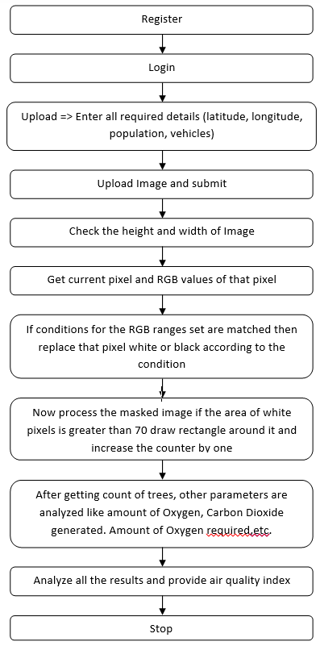

Fig.3.1 Flowchart for proposed concept

**3.3 UML Diagrams**

**3.3.1 Sequence Diagram**

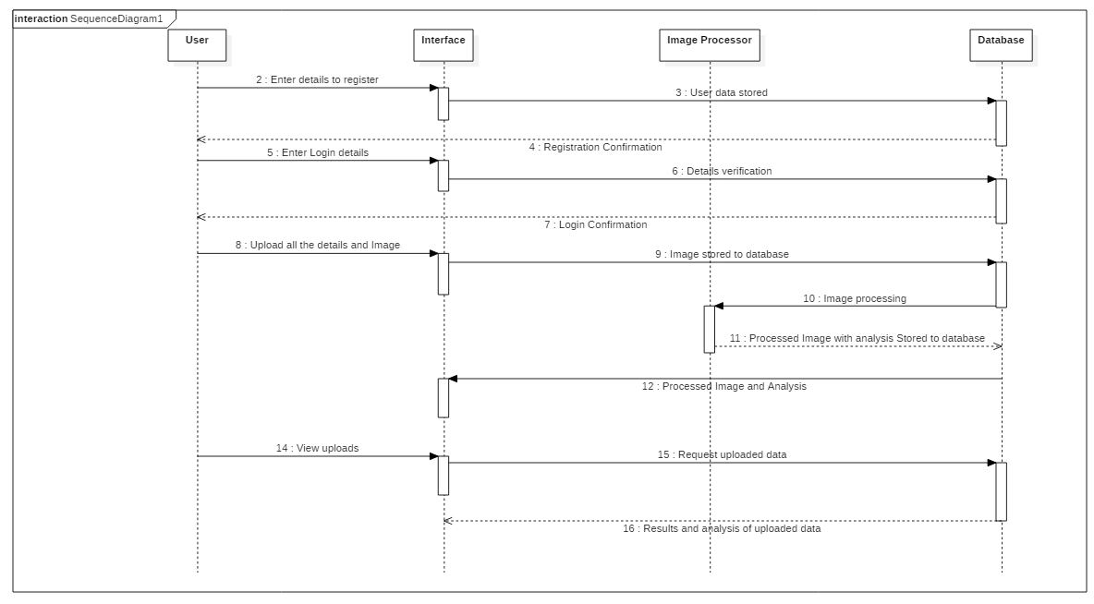

**3.3.2 Use Case Diagram**

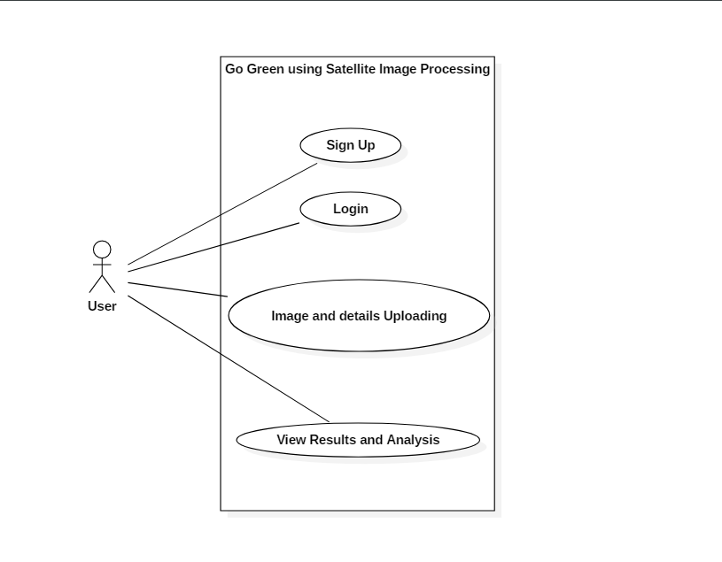

**3.3.3 Component Diagram**

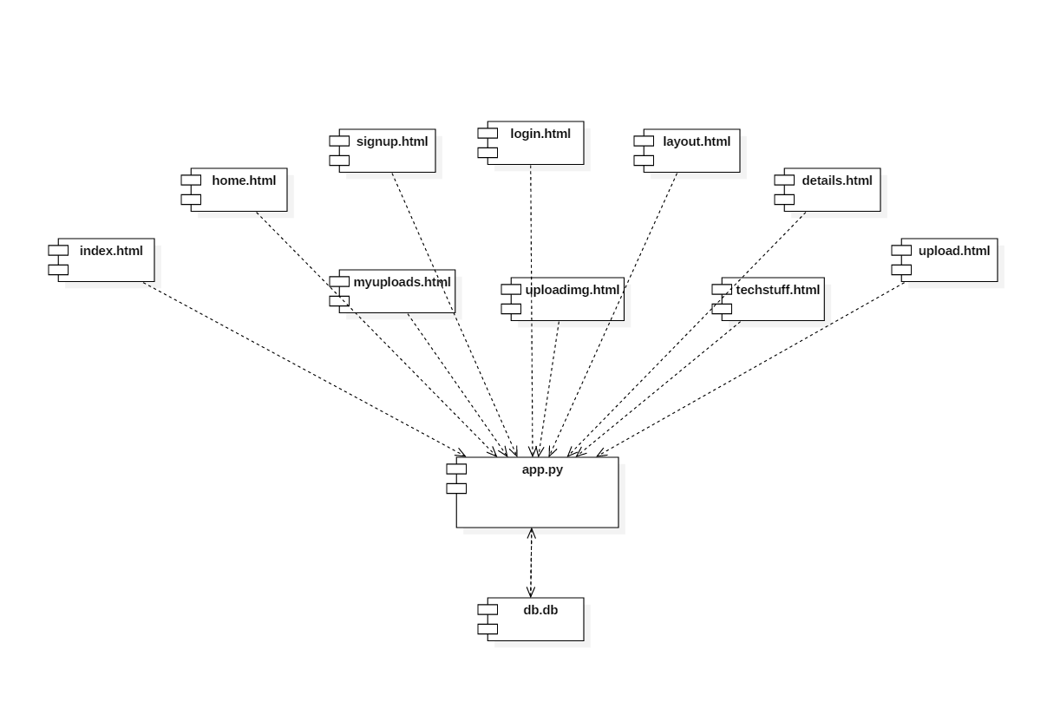

**3.3.4 Deployment Diagram**

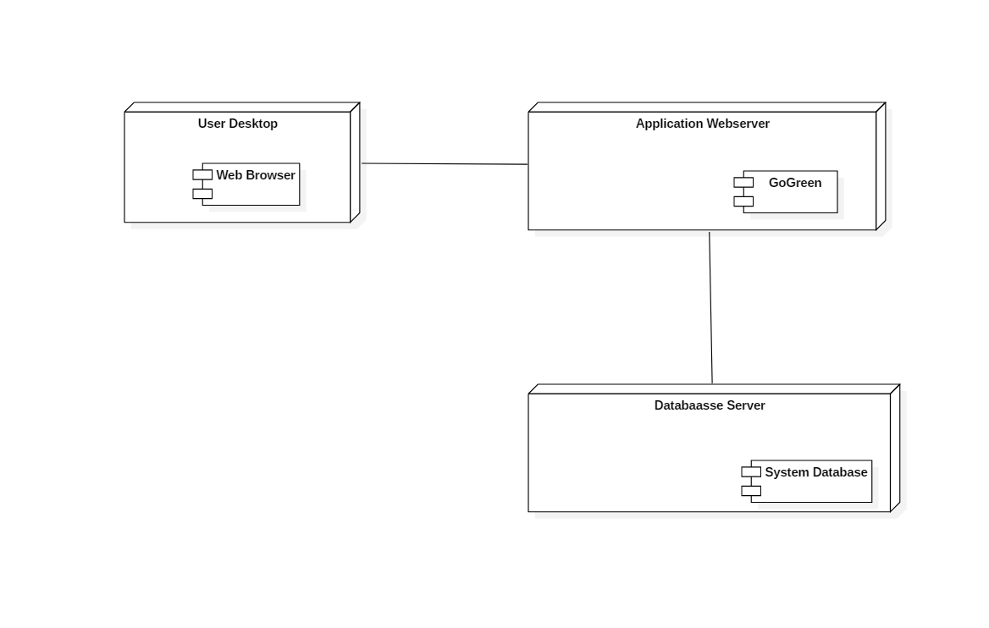

**3.3.5 State Chart Diagram**

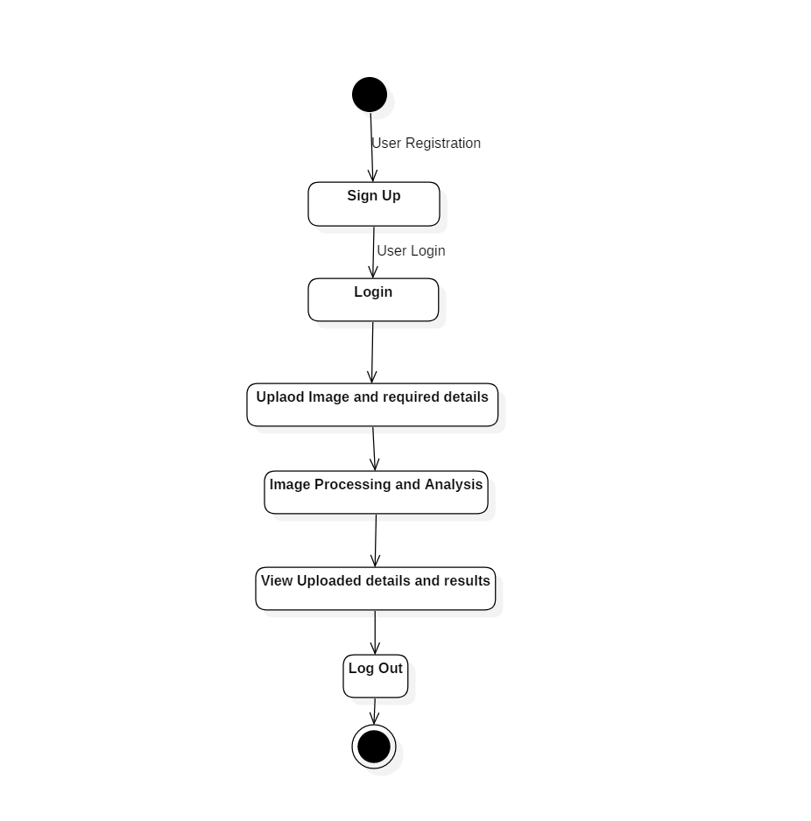

**3.3.6 Data Flow Diagram**

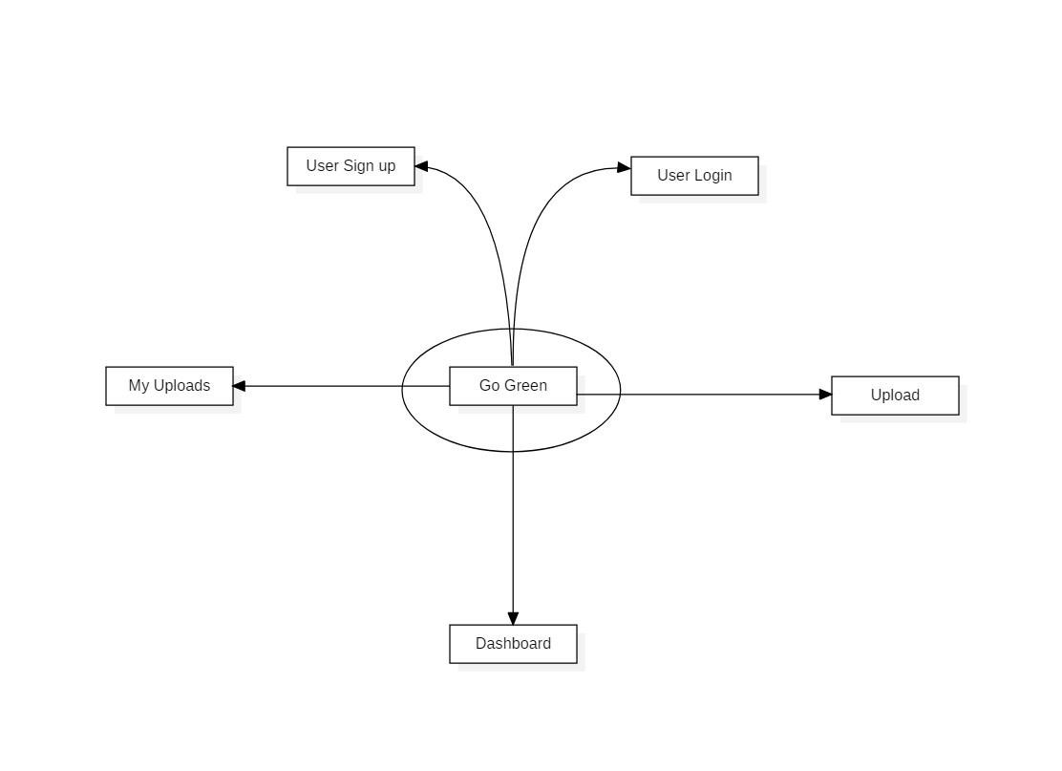

**3.3.7 Activity Diagram**

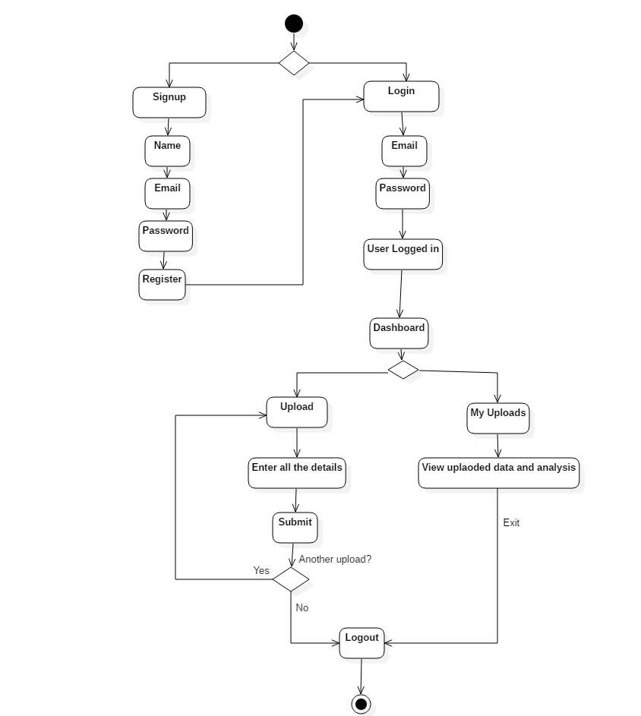

**Chapter 4**

**System Design**

**4.1 Reading the image through Web-input:**

The image is loaded from the text and checked if it matches to the dimensions as mentioned. Then is copied in other temporary variables and displaying the image on the screen.

image = Image.open(path)

image.show()

width, height = image.size

if (width==1280 and height==720):

* 1. **Calculating pixels with Green shade:**

Comparing the value of RGB, if green shade pixels are found then they are separated and replaced with the white pixels. This image is saved as masked image.

for x in range(width):

for y in range(height):

r, g, b = image.getpixel((x, y))

if (r >= 0 and b >= 0):

if (r < g and b < g):

zz = g - r

xx = g - b

if (zz > 10 and xx > 10):

green = green + 1

image.putpixel((x, y), (255, 255, 255))

else:

image.putpixel((x, y), (0, 0, 0))

else:

image.putpixel((x, y), (0, 0, 0))

else:

image.putpixel((x, y), (0, 0, 0))

a = a + 1

image.show()

image.save("mask.jpg")

* 1. **Excluding all the pixels:**

In this all the pixels other than the green shade are excluded from the image, i.e. all the other pixels other than green pixels are replaced by black pixels.

r, g, b = image.getpixel((x, y))

if (r >= 0 and b >= 0):

if (r < g and b < g):

**4.4 Creating rectangular box around contour:**

If the pixels of white color are greater than 70 then the rectangle is drawn around that area and the counter is increased by one and we get the final count of total number of trees. After processing of image, the processed image is saved as contour.jpg

img=cv2.pyrDown(cv2.imread("static/img/mask_"+filename,cv2.IMREAD_UNCHANGED))

ret, threshed_img = cv2.threshold(cv2.cvtColor(img, cv2.COLOR_BGR2GRAY), 127, 255, cv2.THRESH_BINARY)

contours,hier=cv2.findContours(threshed_img,cv2.RETR_TREE,cv2.CHAIN_APPROX_SIMPLE)

coo = 0 #counter

for c in contours:

x, y, w, h = cv2.boundingRect(c)

aa = (w) * (h)

if aa > 70:

cv2.rectangle(img, (x, y), (x + w, y + h), (0, 255, 0), 2)

coo = coo + 1

else:

cv2.rectangle(img, (x, y), (x + w, y + h), (0, 0, 0), -1)

**4.5 Analysis:**

**4.5.1 Amount of Oxygen released in Region:**

Amount of Oxygen released by each tree per year = 120kg = 120000g

Density of Oxygen = 1.43 kg/m3

Oxygen released by each tree per day per minute = (120000/(1.43*365*24*60)) = 0.16 litres/min

Oxygen Released per day by each tree = 0.16*24*60 = 230.4 litres/day

Oxygen released in air of the region = (230.4*number of trees) litres

**4.5.2 Amount of Oxygen consumed by human:**

Intake of air = 8 litres of air/minute

Amount of Oxygen in air = 20%

Amount of Oxygen exhaled in air = 15%

Rate of Oxygen consumption = 8*(20%-15%) = 0.4 litres/min

Oxygen consumed per day per human = 0.4*60*24 = 576 litres

**4.5.3 Amount of Carbon Dioxide generated:**

Amount of Carbon Dioxide released by each human = 454 litres/day

Density of Carbon Dioxide = 1.98 kg/m3

Amount of Carbon Dioxide released by various vehicles in the region:

a) Motorcycle (<100cc) = 0.0325kg/km = (0.0325*1000)/1.98 = 16.86litres/km = 16.86*0.26*number of motorcycles

b) Car (<1000cc) = 0.117kg/km = (0.117*1000)/1.98 = 59.09*0.26*number of car

c) Bus (<6000cc) = 0.5928kg/km = (0.5928*1000)/1.98 = 299.39*0.26*number of buses

d) Carbon Dioxide consumed by single tree every day = 30.13*number of trees in region

e) Total Carbon Dioxide generated in the region = Carbon Dioxide released by humans + Carbon Dioxide released by Motorcycle + Carbon Dioxide released by Car + Carbon Dioxide released by Bus – Total Carbon Dioxide absorbed by Trees

**Chapter 5**

**Results and Discussion**

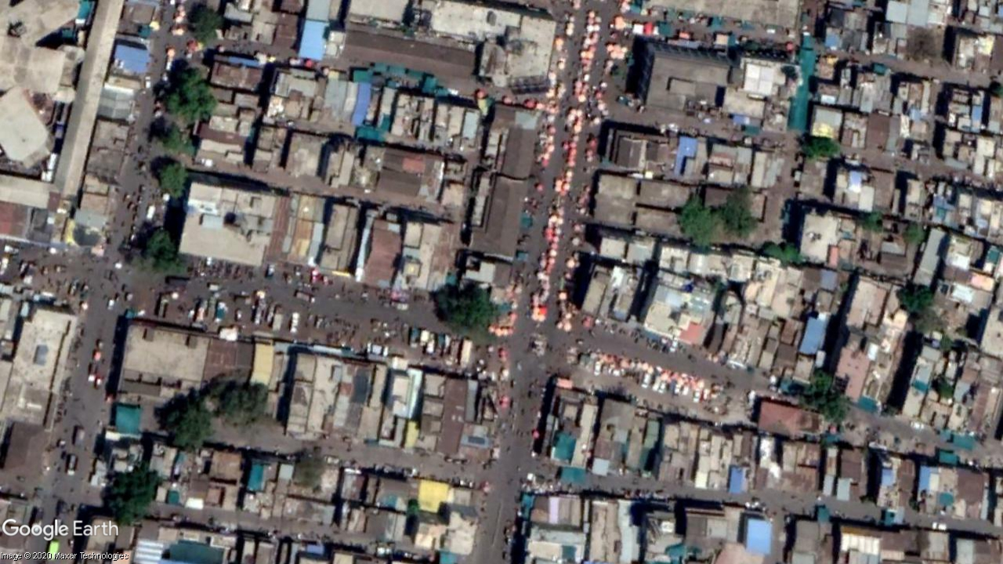

**Fig 5.1 Original Satellite Image**

This image has been taken from the Google Earth Pro Software from the height of 500 meters

This image has the location:

Latitude = 21°00`41.67” N

Longitude = 75°34`23.49” E

Height = 500m

Area covered = 0.66 ${Km}^{2}$

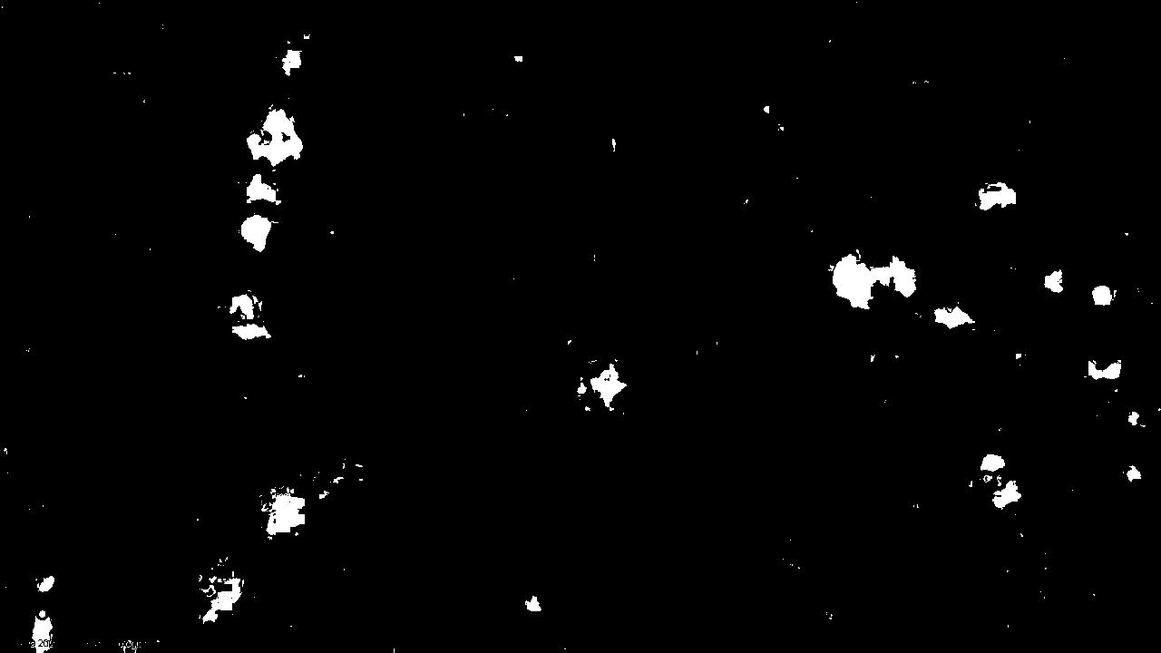

**Fig 5.2 Masked Image**

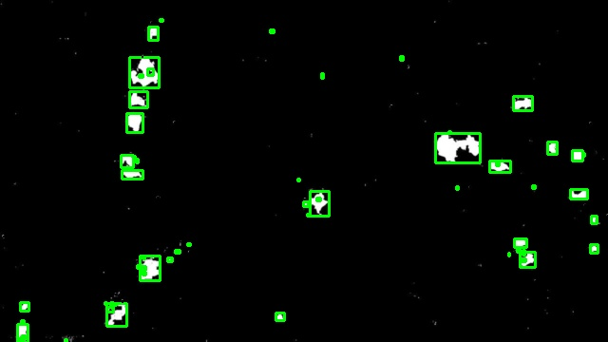

**Fig 5.3 Contour Image**



**Fig 5.4 Sign-up Window**

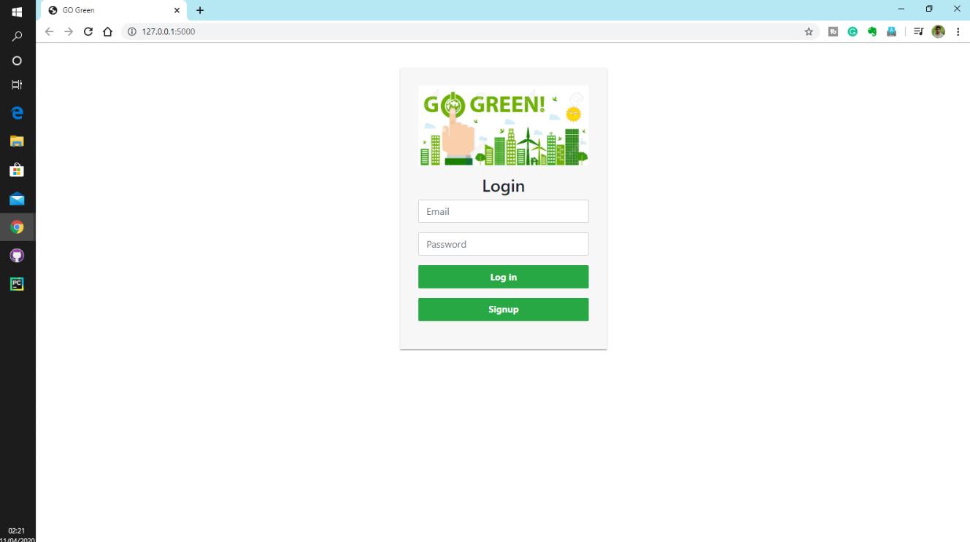

**Fig 5.5 Login Window**

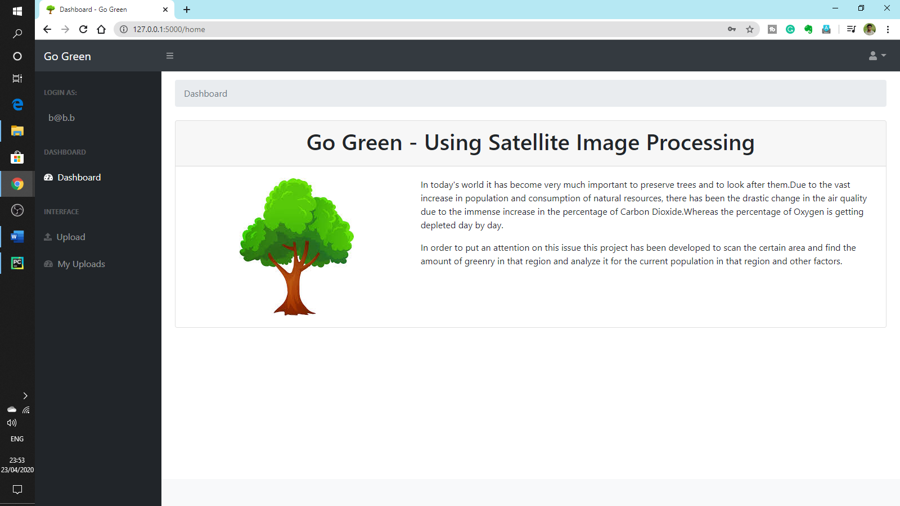

**Fig 5.6 Dashboard Window**

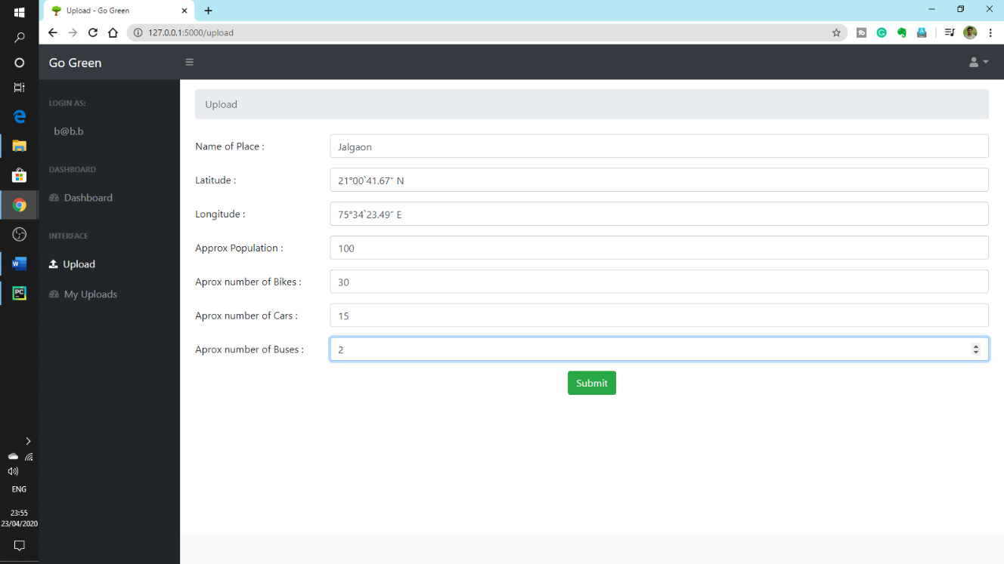

**Fig 5.7 Upload Window**

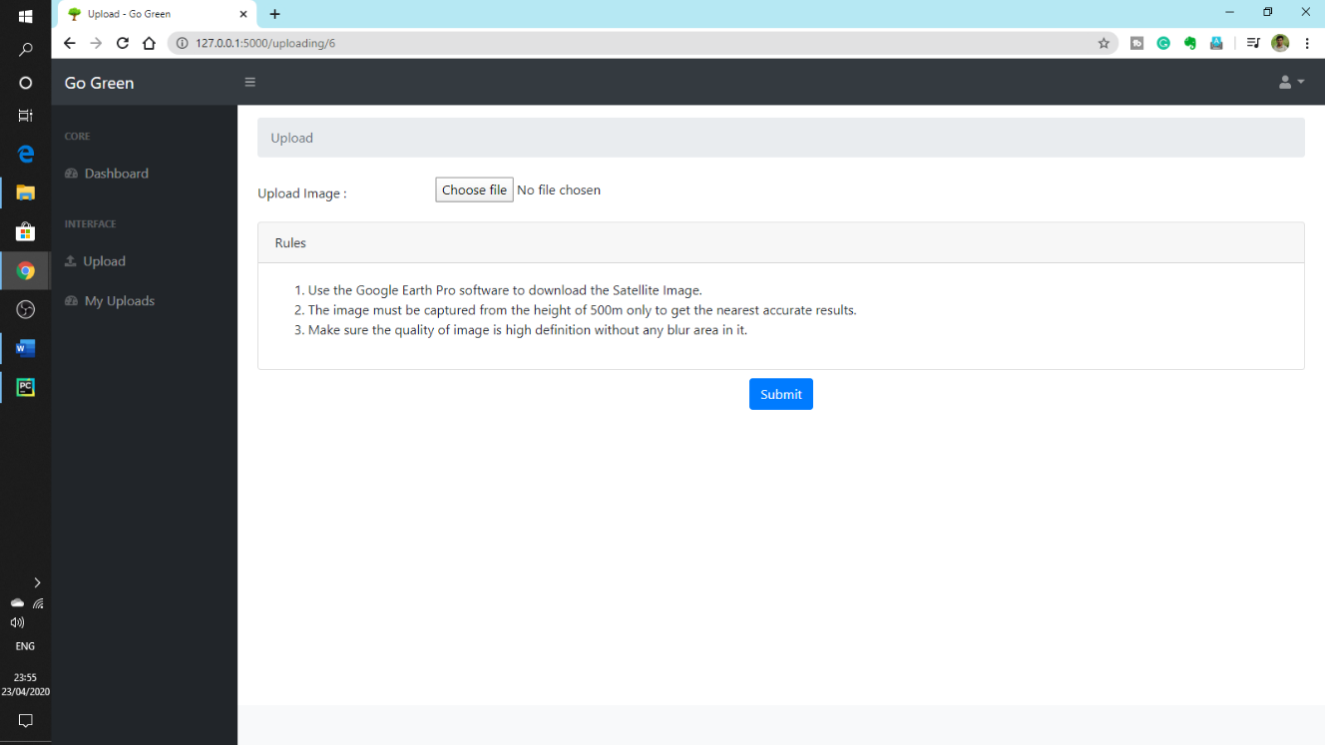

**Fig 5.8 Upload Image Window**

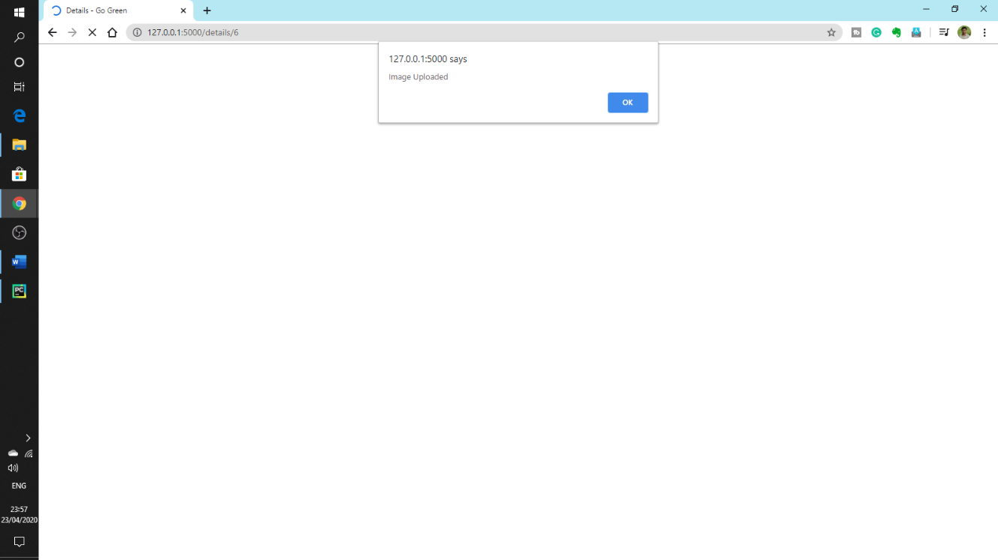

**Fig 5.9 Image Upload Successful Window**

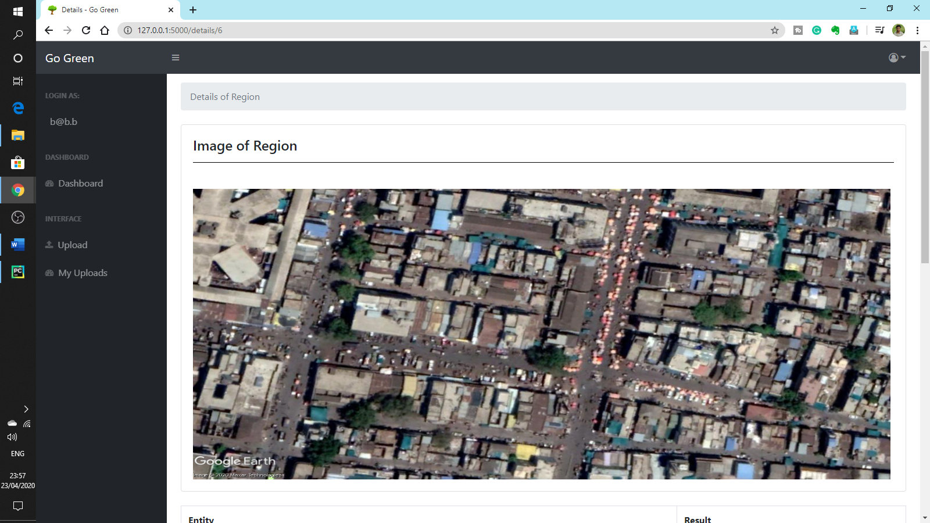

**Fig 5.10 Image Report Window**

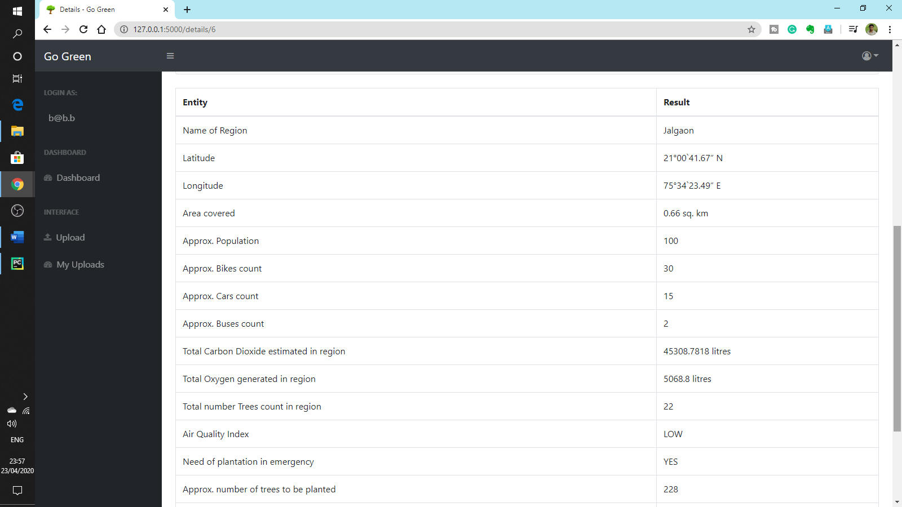

**Fig 5.11 Report Window**

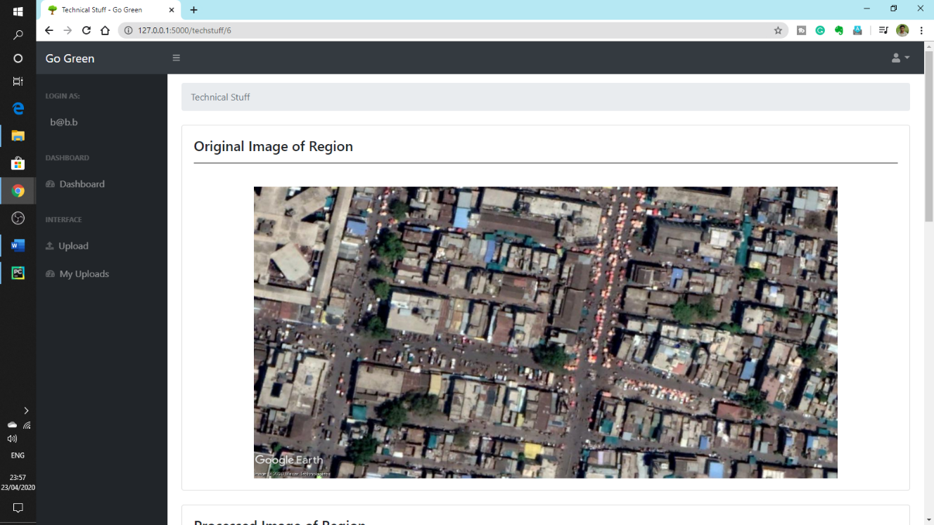

**Fig 5.12 Technical Stuff Window**

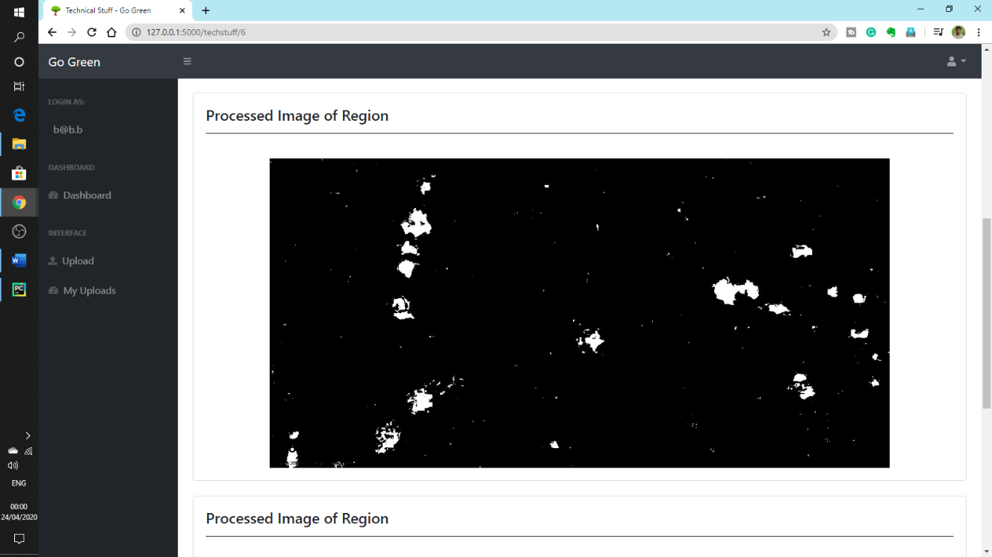

**Fig 5.13 Technical Stuff Window**

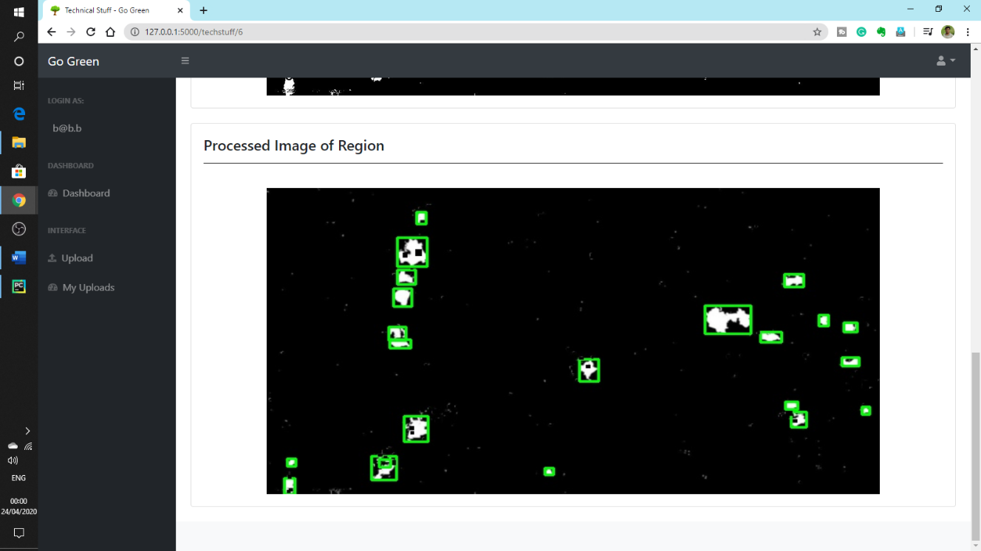

**Fig 5.14 Technical Stuff Window**

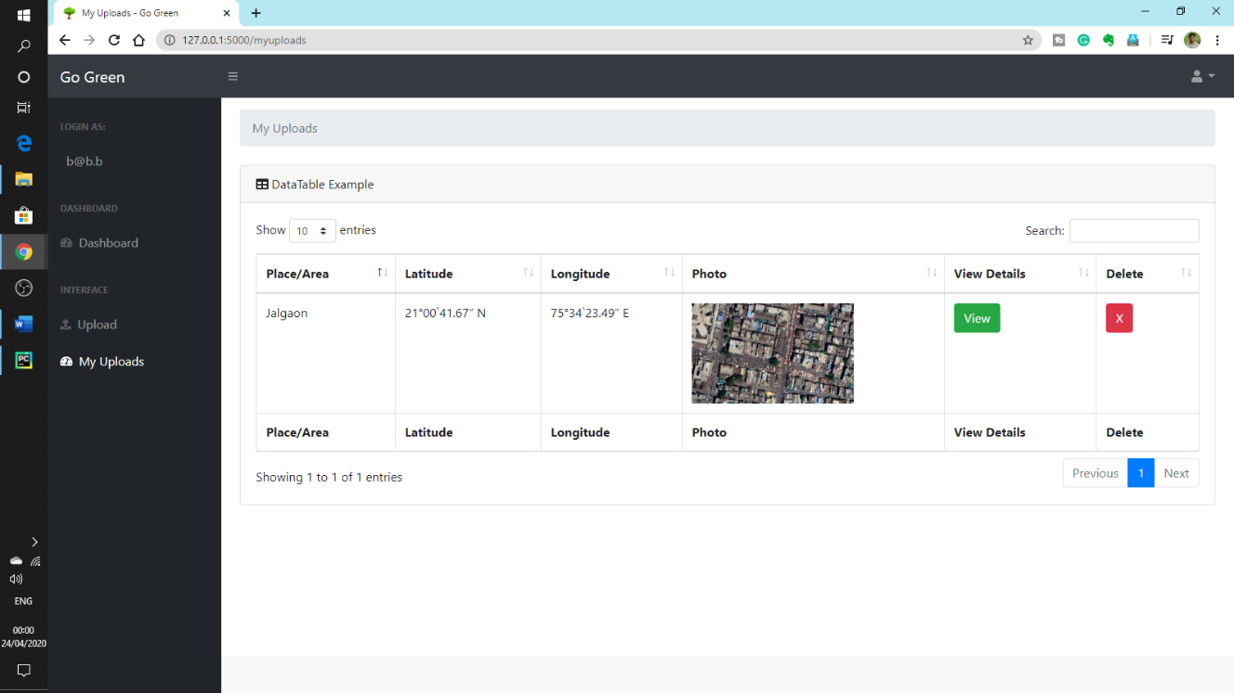

**Fig 5.15 My Uploads Window**

**Chapter 6**

**CONCLUSION AND FUTURE SCOPE**

The main approach of this system is to count the number of trees using the satellite image processing of the image of region provided. Hence, the extension of this work will focus on detection of species of tree through Google Earth Pro Image. By detecting specific species of tree, we can calculate accurate amount of oxygen release and carbon dioxide absorbed by that tree. Also, we can cover large area for detection of tree for example, detection of tree for entire city. And the advanced algorithms for fast and accurate counting of trees and further more analysis on it. After reviewing all above mentioned techniques and methods we can conclude that in this method of counting trees on further more research can give maximum accuracy.

Each has some advantages as well as limitations. Therefore, there is scope of improvement in the existing research. Image processing is a technique which helps to improve all existing research and which will give fast and accurate result**.**

**REFERENCES**

# [1] Tayyeba Javed, Khurram Kamal and Senthan Mathavan, “Identifying tree species from google earth imagery: Detection of Palmyra trees in northern Sri Lanka”, Conference: 2017 23rd International Conference on Automation and Computing (ICAC).

[2] P. Srestasathiern and P. Rakwatin, “Oil Palm Tree Detection with High Resolution Multi-Spectral Satellite Imagery”, Remote Sensing, 2014, Vol. 6, pp: 9749-9774.

[3] Rajagopal Kannan, “Breathing Rates and Breathing Air Constituents”, IJISET - International Journal of Innovative Science, Engineering & Technology, Vol. 2 Issue 4, April 2015.

[4] <https://www.ncbi.nlm.nih.gov/pubmed/9066318>

[5] “National Air Quality Index”, Central Pollution Control Board (Ministry of Environment, Forests & Climate Change) Government of India Website: <https://www.cpcb.nic.in/> October 2014.

[6] David J. Nowak, Robert Hoehn, and Daniel E. Crane, “Oxygen Production by Urban Trees in the United States”, Arboriculture & Urban Forestry · May 2007.

[7] Abhijit Mitra, Tanmay Ray Chaudhuri, Nabonita Pal, Sufia Zaman and Ankita Mitra, “Oxygen Generation by Dominant Urban Trees: A Case Study from Konnagar Municipality, West Bengal, India”.

[8] Rameshwar Mali, Pradip Solanke, Eknath Misal, Sachin Kahandal, Department of Electrical Engineering, SKNSITS, Lonavala, Maharashtra, India “Energy Optimization Using Greenest Possible Source of Electrical Energy to Increase Efficiency of Human Lives”

[9] <https://shaktifoundation.in/wp-content/uploads/2017/06/WRI-2015-India-Specific-Road-Transport-Emission-Factors.pdf>

[10] <https://www.globe.gov/explore-science/scientists-blog/archived-posts/sciblog/2008/08/11/release-of-carbon-dioxide-by-individual-humans/comment-page-1/index.html>

[11] <https://www.sciencefocus.com/planet-earth/how-much-does-human-breathing-contribute-to-climate-change/>